AI EXPENSE TRACKER
Project Report

1. Overview
AI Expense Tracker is a full-stack personal finance system that captures bank transaction SMS messages from an Android phone, stores them through a Node.js and MongoDB backend, and presents spending analytics in a React dashboard. The system focuses on automatic transaction capture, category-based tracking, budget monitoring, AI-style finance assistance, and exportable reports.

2. Objectives
- Automatically detect transaction SMS messages and convert them into structured expense records.
- Provide monthly expense, income, category, and trend analytics through a responsive dashboard.
- Support budgets, recurring expense tracking, PDF/CSV export, and assistant-style financial questions.
- Maintain user isolation so one user logout/login cycle does not mix transaction data.

3. Technology Stack
Layer | Technology
Mobile | Android Kotlin, BroadcastReceiver, WorkManager, Retrofit
Backend | Node.js, Express, MongoDB, JWT, Helmet, CORS, Swagger
Frontend | React 18, Vite, Tailwind CSS, Recharts, Axios, jsPDF, PapaParse
Database | MongoDB collections for users, transactions, budgets, and merchant categories

4. Architecture
The Android app receives or reads SMS messages and sends parsed transactions to /api/transactions/direct. The backend validates required fields, creates or finds the direct user, categorizes merchants, deduplicates by raw SMS, and stores the record in MongoDB. The React website loads insights, transactions, and budgets from direct endpoints, then visualizes them using charts and summary cards.
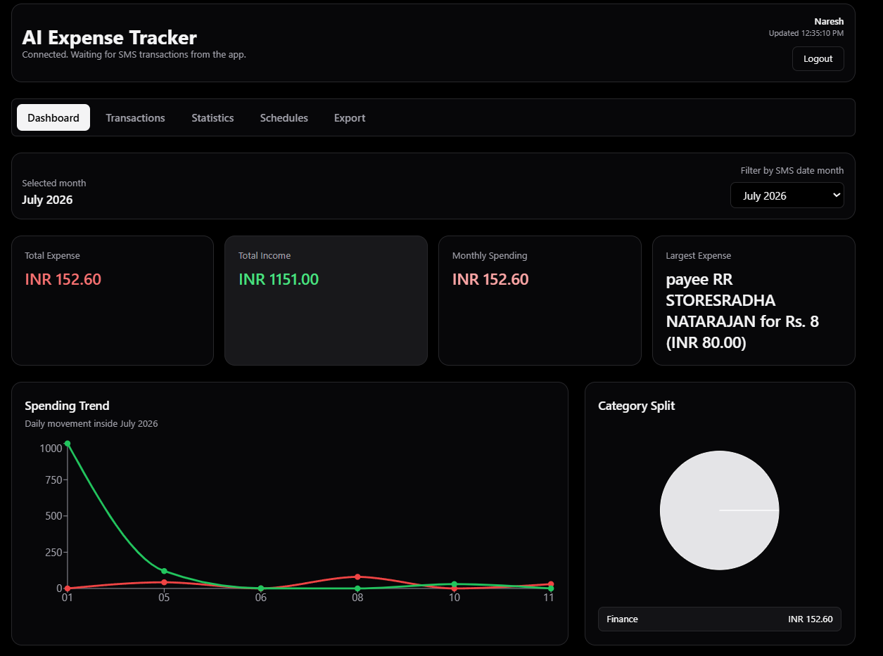
5. Main Modules
Android SMS Collector: MainActivity handles connection and permissions, SmsReceiver reacts to new SMS broadcasts, SmsParser extracts amount/type/merchant/date, and SmsSyncWorker uploads parsed transactions in the background.
Backend API: app.js defines health checks, session creation, authentication, transaction ingestion, insights, budgets, chat, and history clearing. MongoDB indexes improve lookup speed and enforce unique users.
Website Dashboard: App.jsx manages login, selected month filtering, five-second refresh, charts, transaction table, assistant questions, recurring schedules, and PDF/CSV export.

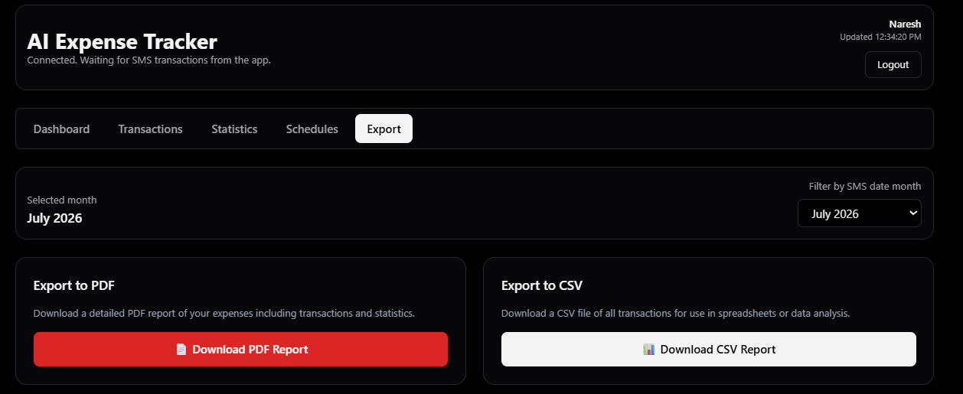

6. Key Features
- Automatic SMS parsing and sync from Android.
- Month-wise transaction filtering and analytics.
- Dashboard cards for expense, income, monthly spending, and largest expense.
- Charts for daily movement, category split, and spending by category.
- Budget comparison, prediction, savings suggestion, AI assistant, and export features.
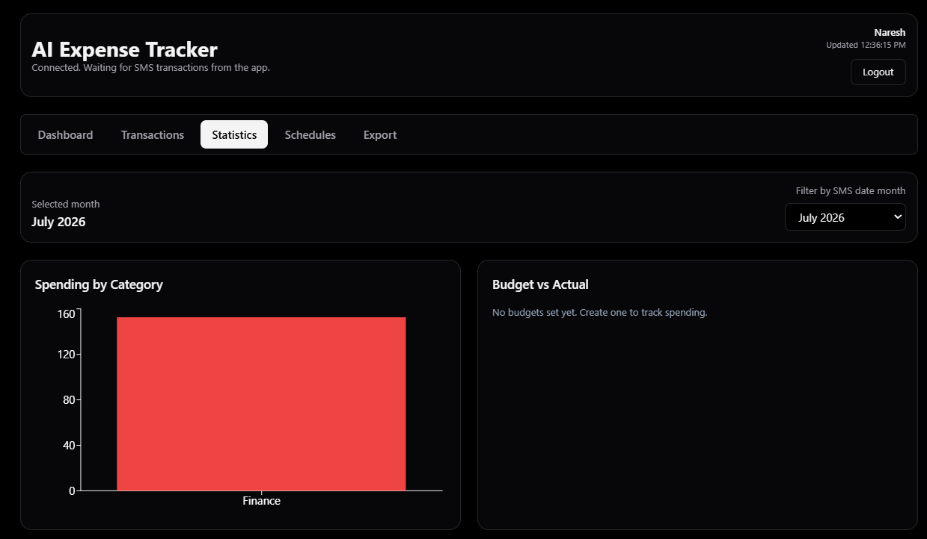

7. Security And Reliability
JWT is used for authenticated API routes, while direct endpoints support the SMS collector and website direct mode. Helmet adds safer HTTP headers, CORS controls browser access, required field checks prevent incomplete records, and session IDs in the frontend prevent stale async responses from leaking into a new user session. WorkManager retry behavior improves Android sync reliability.

8. Data Model
Collection | Purpose
users | Stores email, name, optional Google ID, and creation time.
transactions | Stores user ID, amount, merchant, type, category, date, raw SMS, and creation time.
merchantCategories | Caches merchant-to-category mappings per user.
budgets | Stores category budget limits for a selected month.

9. Testing And Validation
Existing Android unit tests validate SMS amount/type/merchant parsing and backend host URL construction. Manual testing should include backend health checks, Android connection, SMS permission flow, inbox sync, dashboard refresh, chart rendering, AI chat, budgets, logout/login isolation, PDF export, and CSV export.

10. Conclusion
The project demonstrates a practical end-to-end finance tracker with mobile data collection, API-based storage, and a useful analytics dashboard. Its strongest technical points are SMS-to-transaction automation, MongoDB-backed analytics, session isolation, export support, and a finance assistant that can use either Gemini or local rule-based responses.

